Investigating the sources, contributions, and composition of dust in the Salt Lake region: an understudied contributor to PM2.5 and air quality

Daniel K. Jones1, Daniel Mendoza2, Scott Hynek1, Annie Putman1,3, Dale Griffin4, Keith Loftin5

1. U.S. Geological Survey, Utah Water Science Center, West Valley City, UT

2. University of Utah, Department of Atmospheric Sciences, Salt Lake City, UT

3. University of Utah, Department of Geology & Geophysics, Salt Lake City, UT

4. U.S. Geological Survey, Geological Division, Tallahassee, FL

5. U.S. Geological Survey, Kansas Water Science Center, Lawrence, KS

The Great Salt Lake (GSL) continues to desiccate from its historic high stand in 1986 due to water diversions compounded by ongoing drought conditions. The shrinking lake area exposes lakebed sediments. Recent observed dust emissions from exposed lakebed sediments in Farmington Bay have raised questions about the source, transport, fate, and health effects of this dust. A new collaborative effort between the U.S. Geological Survey, the Utah Division of Air Quality (UTDAQ), and the University of Utah has begun to investigate dust in the GSL region. Passive dust samplers have been placed around the GSL and in surrounding communities to collect wind-eroded material originating from GSL source areas (see figure). The sampler-collected material will be compared to paired surface sediment samples collected from exposed lakebed as well as other potential regional dust-source areas to determine the impact of locally derived aeolian material from the GSL on the dust flux and composition in northern Utah. Additional meteorological information from MesoWest and the UTDAQ will be used in particle tracking models to further connect collected dust materials to potential local and regional source areas. All collected material will be analyzed for geochemistry, microbial ecology, fungal pathogens, and cyanotoxins to assess human health threats posed by the dust. Findings will be compiled into a Geographic Information System (GIS) along with demographic and public health information to assess health risks to surrounding communities of the GSL. This work will be the first attempt to quantify the full breadth of human health issues related to wind-eroded dust from the GSL and will provide a foundation for understanding current and future health risks posed by lowered lake levels. This talk will present an overview of the project, justification, site selection process, and initial findings from the first round of sampling conducted in 2018.

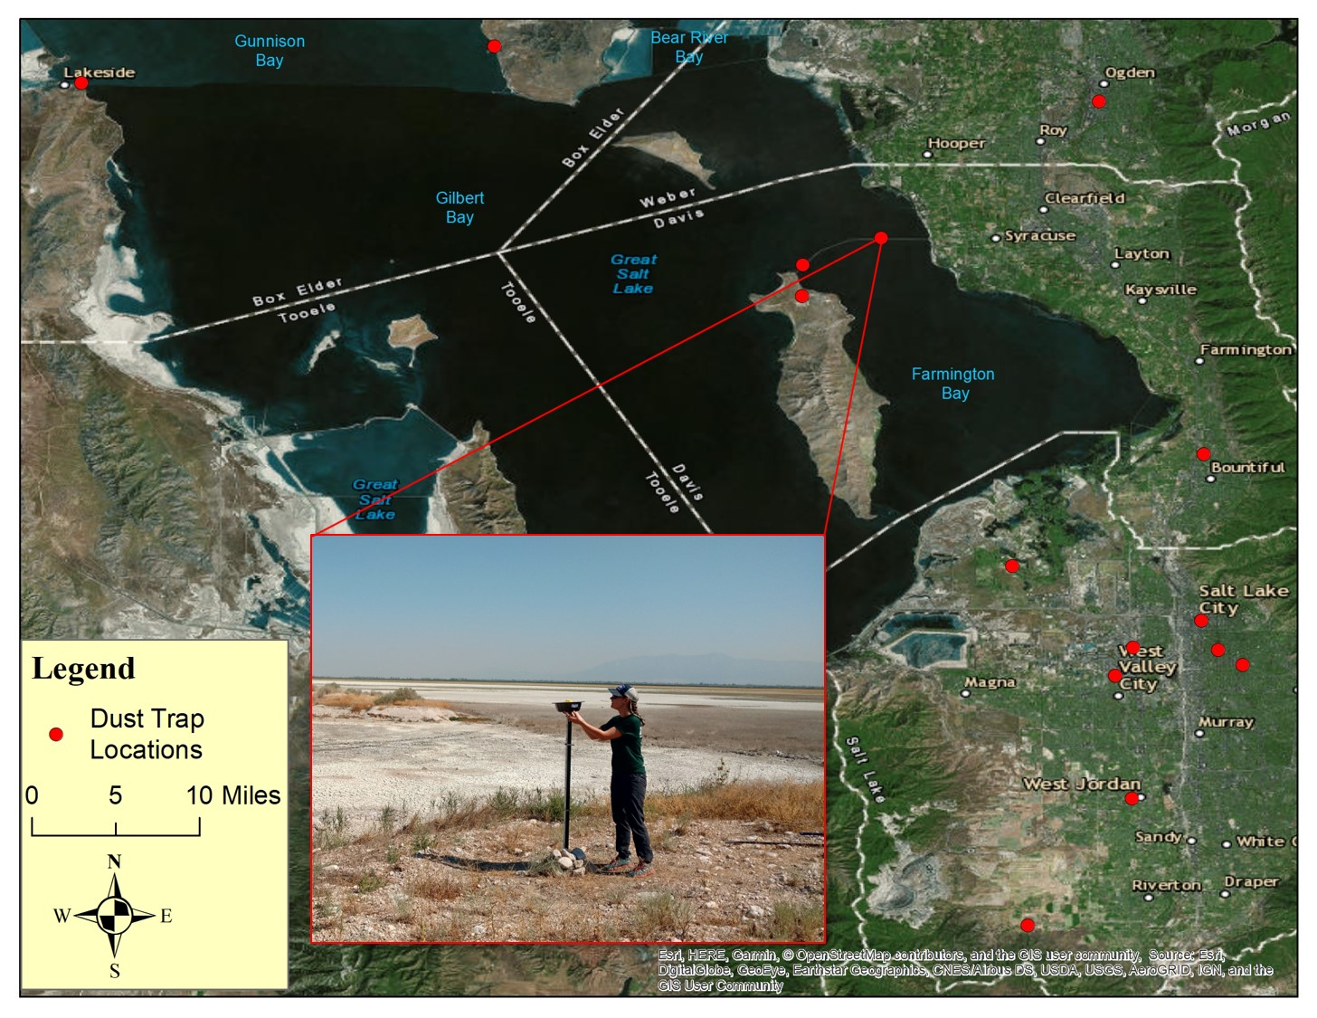

Dust-trap locations deployed by the U.S. Geological Survey in the Salt Lake valley. Dust-traps consist of a metal non-stick bundt cake pan with marbles typically mounted on a 1.5-meter pole.